### **Communities**

**Question 1**:

For the following graph:

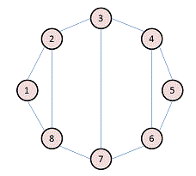

Write the adjacency matrix A, the degree matrix D, and the Laplacian matrix L. For each, find the sum of all entries and the number of nonzero entries.

Adjacent matrix:

1. 2 3 4 5 6 7 8

1 0 1 0 0 0 0 0 1

2 1 0 1 0 0 0 0 1

3 0 1 0 1 0 0 1 0

4 0 0 1 0 1 1 0 0

5 0 0 0 1 1 0 0 0

6 0 0 0 1 1 0 1 0

7 0 0 1 0 0 1 0 1

8 1 1 0 0 0 0 1 0

Number of non-zero entries = 22, Sum of all elements = 22

Degree Matrix:

1. 2 3 4 5 6 7 8

1 2 0 0 0 0 0 0 0

2 0 3 0 0 0 0 0 0

3 0 0 3 0 0 0 0 0

4 0 0 0 3 0 0 0 0

5 0 0 0 0 2 0 0 0

6 0 0 0 0 0 3 0 0

7 0 0 0 0 0 0 3 0

8 0 0 0 0 0 0 0 3

Number of non- zero entries = 8, Sum of all entries = 8

Laplacian matrix(L=D-A):

1. 2 3 4 5 6 7 8

1 2 -1 0 0 0 0 0 -1

2 -1 3 -1 0 0 0 0 -1

3 0 -1 3 -1 0 0 -1 0

4 0 0 -1 3 -1 -1 0 0

5 0 0 0 -1 2 -1 0 0

6 0 0 0 -1 -1 3 -1 0

7 0 0 -1 0 0 -1 3 -1

8 -1 -1 0 0 0 0 -1 3

Number of non-zero entries = 30, Sum of all entries = 0

**Question 2**:

Consider the following undirected graph (i.e., edges may be considered bidirectional):

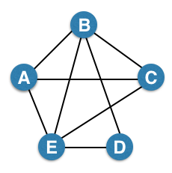

Run the "trawling" algorithm for finding dense communities on this graph and find all complete bipartite subgraphs of types K3,2 and K2,2. Note: In the case of K2,2, we consider {{W, X}, {Y, Z}} and {{Y, Z}, {W, X}} to be identical.

From the graph

A={B, C, E},B={A, C, D, E},C={A, B, E}, D={B, E},E={A, B, C, D}

So, B and E have support more than 3 Therefore, Bipartite subgraph of K3,2

1)A B

C E

D

A={B,E} C={B,E} D={B,E}

Bipartite subgraph of K2, 2

1)A C 2)B A 3)B A

B E E D E C

A={C,E} B={C,E} B={A,D} E={A,D} B={A,C} E={A,C}

4)B A 5)B C

C E E D

B={A,E} C={A,E} B={C,D} E={C,D}

**Question 3**:

We fit AGM to the network on the left, and found the parameters on the right:

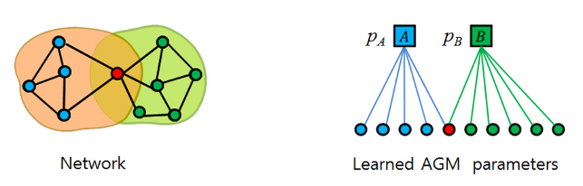

Find the optimal values for pA and pB.

pA=no.of edges in the network/total possible number of edges=7/5c2==>7/10==>0.7

pB=no.of edges in the network/total possible number of edges=9/6c2==>9/15==>0.6